SSS Number Registration Process in Pasig Mabini Branch Simulation

**Bracamonte, Miguel Andrew**

*Technological University of the Philippines – Manila*

*College of Science*

*Computer Science miguelandrew.bracamonte@tup.edu.ph*

**Osila, Shayne Rose**

*Technological University of the Philippines – Manila*

*College of Science*

*Computer Science shaynerose.osila@tup.edu.ph*

**Pielago, Czarina**

*Technological University of the Philippines – Manila*

*College of Science*

*Computer Science czarina.pielago@tup.edu.ph*

***Abstract*—SSS is a social insurance program mandated by the Philippine government for workers in the private and informal sectors. Some beneficiaries were protected against the risks of disability, sickness, maternity, old age, death, and other contingencies that resulted in income loss and financial burden. During the transaction, all SSS members with a monthly income are required to contribute to the fund. It is critical to provide members with a proper transaction process. Therefore, the SSS transaction process specifically for SSS number registration in Mabini Branch, Pasig City has been chosen for this proposed simulation. Throughout the process, the simulation system will determine various possibilities or scenarios.**

***Keywords*—** **Simulated Transaction Process, Social Security System, Simulation, Regression Analysis**

# **I.** **INTRODUCTION**

Insurance is critical to economic activity and the long-term viability and growth of the national economy. Few individuals and entities can effectively protect their property ownership and other economic rights without the use of insurance. However, insurance can still be useful to prepare for possible risks. The Social Security System (SSS) is one of these insurance programs, hence the employees' compensation benefit (or disability benefit) is a compensation package for private-sector employees and their dependents in the event of a work-related injury, sickness, disability, or death. The president and CEO of the said Social Security System, Michael Regino, stated that recognizing the importance of providing easier and more convenient modes of transaction for stakeholders, can eliminate overcrowding and long queues in various branches.

The transaction process performs the routine transactions necessary for a particular program or company. It consists of systematic steps to properly conduct a process of transactions. One of these is the query support which will be focused throughout the simulation. This transaction would undergo different phases: data entry, data validation, data processing, and revalidation, storage, output generation, and query support [1]. Moreover, it is aimed at controlling customer flow and streamlining in queueing experience. The insurance program can effectively increase the speed of each transaction and reduce customer waiting time. Some processes transactions in real-time, while others collect transaction information over time and process it later on often after business hours [2]. Using a transaction process ensures that customer transactions are processed quickly and accurately.

It is necessary to establish the processing time and the number of people who will be able to attend during this type of process. Another method for evaluating this is to stochastically simulate all possible scenarios. This will also help to prevent such errors that may occur and to be more prepared in any situation. Furthermore, a simulated transaction occurs when the parties structure their transaction to achieve an objective other than the one that appears on the face of the agreement. It may arrange their affairs to avoid a statutory prohibition as long as it does not result in a simulated transaction in fraud of the legislation [3]. Our goal here is to create a model that will allow us to study random situations during overall insurance transactions. To do this, we simulate individual firms and the perils they ensure, but we also simulate how firms set times and processes, how they manage the people visiting, and how these actions affect each other [4].

# II. BACKGROUND

## AnyLogic

Build an interactive simulation of your business; it's like a video game where you can test changes at any level of detail, communicate ideas through dynamic animation, and collect statistics. A simulation model is a risk-free environment, less expensive than real life experiments and much more flexible and intuitive than formula-based simulations Excel models. AnyLogic has built-in industry-specific modeling toolkits which speedup simulation of any complexity and scale. That is why AnyLogic has become the number one simulation tool in logistics, manufacturing, mining, oil and gas, healthcare, rail and other industries. The software's experiment framework allows you to run complex experiments, including those for training AI algorithms.

1. *Regression Analysis*

Finding the variables that have an effect on an interest issue can be done with accuracy using regression analysis. You may confidently establish which elements are most important, which ones can be ignored, and how these factors interact by completing a regression. To perform a regression analysis, you must first specify the dependent variable that you believe is being influenced by one or more independent factors. After that, you must create a sizable dataset on which to base your analysis. An excellent technique to create this dataset is to conduct surveys among your target audiences. Each independent variable in your study that you are interested in should be covered by questions in your survey.

# **III.** **REVIEW OF R**ELATED WORKS

PESOLab (2020) released an article recently regarding Filipinos' opportunities to save more than the mandatory contributions and earn passive income in the future. The article talked about how members can invest and avail of the SSS program for a couple of years ago. It was said that the program is a voluntary provident saving program open to members working locally and outside the country. Saying that it is a great option where a member can build up savings as it can be an alternative for those who have spare cash, want to contribute more than what they are giving to their mandatory savings in SSS, wishes to have their savings grow, and get additional benefits in their later years.

Bugante(2016) reported that enrollment in SSS PESO Fund was made more accessible. Members who wish to save more for their retirement through the SSS Personal Equity Savings Option (Peso), a provident-fund scheme aiming to increase savings among members, may enroll in the program through the Web. At their own time and convenience, members may register via the My.SSS website and click the “e-services tab.” A confirmation will be sent to their email once the registration is successful.

iGovphil site (2016) posted that the Integrated Government Philippines (iGovPhil) Program is an initiative envisioned to enable a whole-of-government transition in ICT that would allow strategic integration and better efficiency across government agencies. An integrated approach addresses infrastructure, services, applications, and tools to improve public service and governance through enhanced processes and service delivery.

The government data center (GDC) addresses one of iGovPhil’s goals of building the physical infrastructure to interconnect government agencies. It serves as the launching point for many government services such as cloud computing, web hosting, server colocation, and other operations. Several agencies operate their own data centers or outsource their data center needs. However, the current trend in governments is toward data center consolidation, not only to cut back on costs but to optimize ICT resources and operations and address data security concerns.

The GDC makes faster data exchange and collaboration among government agencies. It provides centralized servers and colocation and storage facilities. Some of the benefits are reduction in government spending, efficiency, and overall IT improvement. Such information and communication technology infrastructure was expected to ensure speedy and efficient government services to the people. This aims to make the government more efficient, transparent, and accountable.

Additionally, the Philippine Information Agency, PIA(2019), posted the partnership between SSS and Globe GCash. Members of the Personal Equity and Savings Option (PESO) Fund of the Social Security System (SSS) may pay their PESO Fund contributions via Globe GCash, the state-run pension fund. Dubbed as the second savings for pension, PESO Fund has more than 17,000 members to date. The GCash facility is a free mobile application exclusive to Globe or Touch Mobile prepaid users and postpaid subscribers. Aside from paying PESO Fund contributions, SSS members can use Globe GCash in paying SSS contributions, salary loans, and real estate loans.

According to Hernani Hadiyati1 (2014) in her study “Service Quality and Performance of Public Sector: Study on Immigration Office in Indonesia”. The objectives of this research are to describe the public sector service form delivered to consumers/citizen, to find out the consumers’ satisfaction on public sector service, and to discover the public sector quality and performance delivered to consumer/people. The research is to measure the level of consumers’ satisfaction in using the public sector services through government policy approach

towards the service satisfaction, and people’s judgment towards the quality and performance served by public service administrator apparatus. This research results in, first, description of the public sector service form delivered to consumers/people as the public sector service users, second, measuring the consumers or people’s satisfaction based on the public sector service satisfaction measurement indicator in reference to government’s decrees and laws, and third, determining the public sector service performance and quality applied to the consumers/people. The result of the research is of benefit for the all members for the governments’s consideration as public sector service administrator for consumer/people in the effort to ameliorate the service performance and quality.

There are a lot of government issued manual of procedures and enacted laws relating to the implementation of social security system. To be able to access SSS anytime anywhere by the SSS members, SSS further improves its services through the launching of the enhanced SSS website wherein members can view and print their records and submit transactions online. An SSS member or employer only needs to have an active email account to be able to register in the web. Exclusivity of records is concept of this program; hence, a member must register with his unique email address and unique user id. Records such as contributions, employment history, static, loan status can be viewed and be printed. Transactions like submission of R1A, R3, salary loan, and maternity notifications are some of its features. In the desire of SSS to further improve its service delivery to members, an Office Order 2012-068 “File Anywhere Policy” was issued so that members can transact business with SSS anywhere that is convenient to him [6].

# **IV.** METHODOLOGY

The stages of research conducted at SSS in Pasig Mabini Branch are as follows:

1. *Data Collection*

The sort of distribution that occurs in the number registration process in the Pasig Mabini branch is identified through data collecting so that Anylogic Software can replicate it. Customers' arrival, the length of the registration procedure, and how long they stay at the service are the three types of data that are employed. At the SSS Pasig Mabini Branch during business hours, data were gathered through direct observation. The average service / process time is the data to be collected.

1. *SSS in Pasig Mabini Branch Layout*

The entire layout is shown in Fig. 1 and Fig. 2 which comprises five counters where SSS number registration transactions will be accepted over the counter. The one counter at the side was for the Fill - out process. The line of applicants arrives at the chairs in the middle. The area is 200 meters by 30 meters. The physical layout of the SSS branch in Pasig Mabini was designed using AnyLogic software.

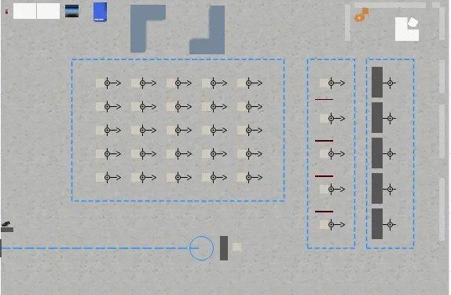

Fig. 1 2D Physical Layout of the SSS Branch in Pasig Mabini

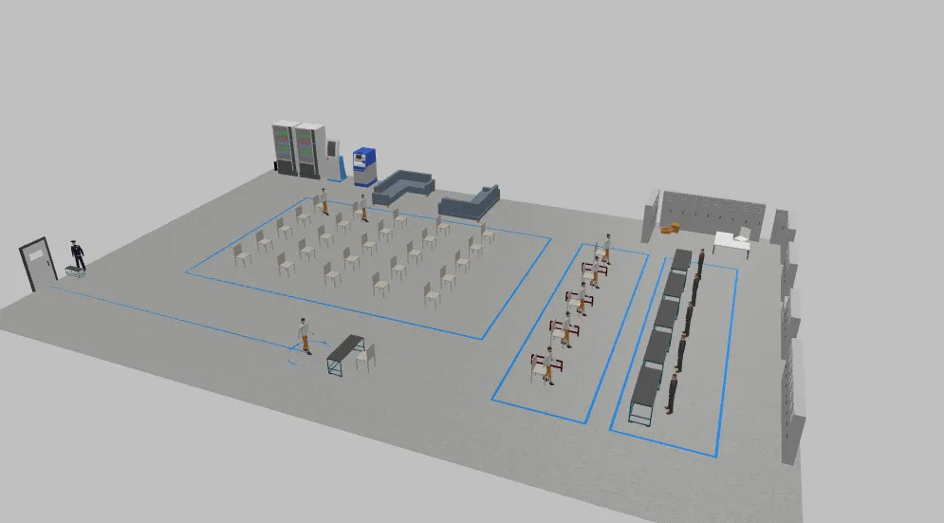

Fig. 2 3D Physical Layout of the SSS Branch in Pasig Mabini

1. *Creating a System Description*

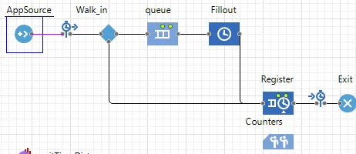

Fig. 3 The SSS registration number processes in Pasig Mabini Branch

The System Flow is shown in Fig. 3 and it is designed using Anylogic Software so that the system design can reduce the number of registration processes and idle time per counter. The system flow consists of the following Process Modeling Blocks:

* AppSource - represents an arrival of applicants, and there is only one instance of it in the model.
* Walk_in Decision - if it is true the applicants will proceed to the fill-out area, if it is false it means the applicants were already registered through online, so it will proceed to the registration area.
* Queue - represents a lane, and there is only one instance of it in the model.
* Fill - out - which is where applicants who have not yet registered online will proceed.
* Register - where SSS number registration transactions will be accepted over the counter.
* People_icon - represents a resource, which is the workers or staff of the SSS branch.
* Sink - represents an exit.

1. *System Design*

The stages in designing this system consist of:

1. Distribution Testing

Distribution testing is performed on the old service data and the time interval of arrival that has been collected during the observation.

1. Making a SSS Number Registration Process Simulation

At this stage the most optimal number registration process simulation is made using Anylogic Software according to the type of arrival time distribution and client service length.

# **V.** **RESULTS**

Based on the survey data gathered during the observation at the SSS Pasig Mabini Branch, a hundred (100) applicants are estimated to apply for number registration in SSS. The operation hours in SSS Pasig Mabini Branch are scheduled from 7 am-5 pm, which consists of a total time of 600 minutes. The data shows the estimated minimum, average, and maximum minutes for each process used in the model in triangular function are as follows.

| ***Process (minutes)*** | **Arrival Rate** | **Fillout Delay Time** | **Register Delay Time** |
| --- | --- | --- | --- |
| *Min* | 0.2 | 3.5 | 10 |
| *Ave* | 0.2 | 5.5 | 25 |
| *Max* | 0.2 | 7.5 | 30 |

***Table 1.* Rate Time Processes**

The figure shows the rate and delay time in minutes applied through the model. This will be used to estimate the number of applicants who successfully complete the whole process of SSS number registration. This table categorizes the minimum, average and maximum of time.

1. Regression Analysis of Data
2. *Interarrival Time and Time in Distribution*

The average arrival time of a simulant is 0.2 to apply randomness using exponential(). On the other hand, the time in distribution measures the time taken during the successful process or service. The total time distribution depends on the arrival rate of simulants. The data analysis in this model determines that if the arrival time of applicants increases, the mean of time in distribution also increases.

| **Arrival Time (exponential[mins.])** | **Time in Distribution (mean)** |
| --- | --- |
| 0.1 | 17.136 |
| 0.2 | 19.68 |
| 0.3 | 23.683 |

***Table 2.* Arrival Time and Time in Distribution Data**

The table 2 shows as the arrival time increases in intervals of 0.1, the mean of time distribution also increases.

1. *Fill Out Queue Mean and Waiting Time Distribution*

The fillout queue determines the size and mean of the applicant queue throughout the process. The waiting time distribution is concerned with the probability distribution of waiting time or queue of applicants, specifically in the fillout process. Another model analysis determines whether the queue mean decreases as the arrival time changes and is dependable in the mean of the waiting time distribution, which also decreases.

| ***Fill Out Queue (mean)*** | ***Waiting Time Distribution (mean)*** |
| --- | --- |
| 0 | 11.653 |
| 0.312 | 12.012 |
| 0.322 | 14.921 |

***Table 3.* Fill Out Queue, Register Length, and Waiting Time Distribution Data**

Table 3 shows that as the arrival time minute changes in intervals of 0.1 in randomness, the fill out queue mean increases, on which the waiting time distribution also dependent and increases.

# **VI.** **CONCLUSION**

This paper presents a real-time simulation of the Social Security System branch in Mabini, Pasig City. This will determine the arrival length and time of each process according to the schedule. This will only present the daily basis of simulation process in registration of SSS numbers. The dynamic method of regression analysis will be used as a foundation to determine the appropriate effect of simulant arrival throughout the entire process. The analysis revealed that the arrival time has a significant effect on the time in distribution and waiting time distribution, as well as the queueing process.

# **References**

[1] Mahajan, Ribhu, Role of Transaction Processing System (December 29, 2009). Available at SSRN: <https://ssrn.com/abstract=1529303> or [http://dx.doi.org/10.2139/ssrn.1529303](https://dx.doi.org/10.2139/ssrn.1529303)

[2] Indeed Editorial Team, What is a Transaction Processing System (TPS)? (2022, February 04) Retrieved from: www.indeed.com/career-advice/career-development/what-is-transaction-processing-system?utm_campaign=earnedsocial%

[3] Bracher, Patrick, What is a simulated or sham transaction? (2014, November 10), Financial Institutions Legal Snapshot. Retrieved from: https://www.financialinstitutionslegalsnapshot.com/2014/11/what-is-a-simulated-or-sham-transaction/

[4] Heinrich, Torsten, and Sabuco, Juan and Farmer, J. Doyne (2019): *A simulation of the insurance industry: The problem of risk model homogeneity.*

[5] Ernani Hadiyati1 (2014) Service Quality and Performance of Public Sector: Study on Immigration Office in Indonesia. School of Economics and Business Faculty, Gajayana University, Malang, Indonesia Correspondence: ErnaniHadiyati, School of Economics and Business Faculty, Gajayana University, Malang, Indonesia.Tel: 62-812-358-4748. E-mail: Lernani_hadiyati@yahoo.com International Journal of Marketing Studies; Vol. 6, No. 6; 2014 ISSN 1918-719X E-ISSN 1918-7203 Published by Canadian Center of Science and Education Received: October 8, 2014 Accepted: November 1, 2014 Online Published: November 24, 2014 doi:10.5 539 /ijms. v6n6 p104 URL: http:// dx. doi. org/ 10. 5539/ijms.v6n6p104

[6] Social Security System Office Order 2012-068 “File Anywhere Policy” Social Security Commission Resolution No. 133 dated February 6, 2014 approval of the Implementing Rules on the No Gift Policy of the Social Security System. https://opinion. inquirer. net/87658/ sss-claims-processing-depends-on-applicants-too#ixzz5ioJ6w3Zj Follow us: @inquirerdotnet on Twitter | inquirerdotnet on Facebook